Elastic load balancer: ----

With Autoscaling ELB..

Scenario 1: if hosted one website --> need one public IP --> request redirect to the perticular service --> response should be return

Auto scaling ---> if load increase second and third server will add, then that time all servers having different different public ip address.. we cant add all 3 public ip's cant add into one domain..

to over come this we can use one load balance that is called elastic load balancer --->> we can add public ips as a target group and public ips can add to ELB , every elastic load balance will give one DNS.. will nt get any private or public ip ..

to connect ELB we use only DNS..

when ever request come that will redirect to ELB.

will get CNAME --> map with the DNS..

ELB will distribute the traffic equally..

why they are not providing public ip and private ip we can see later....

Elastic so if provide the ip that should not able to handle.. so gives CNAME...

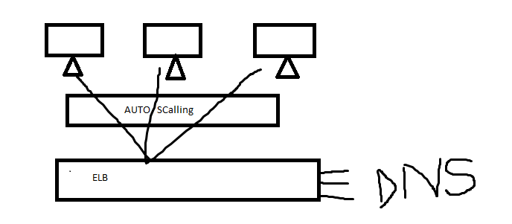

Scenario 2: ----

______________________

With out auto scalling ELB.

Vpc one , public subnet and private subnet..

three tier---> web , application and database

two tier ---> web and application in single group and database difference

one tier --> all in one..

web tier and app tier should be separate..

if any one want to access that should be presence in public subnet then only they can access..

web tier should be place in public subnet.

app tier and database tier should be place in private subnet..

request come to public subnet if any thing need from app tier and dab tier then web tier will connect and give the response..

web hosting in public na may be security issues will come. to over come this they will host in private subnet..

to access this We need to use ELB..

we should place this ELB in public subnet..

this ELB work as a proxy.. here we can place the CNAME connecting with DNS.. when ever request comes that should route to ELB and connect with the web server..

If private subnet having two servers here we need to add as target group(here target groups should be ec2, ecs, IP , Lambda) ---> here elastic load balance will share the request with load balance..

to hide the information regarding server we use ELB..

For creating ELB we need two public subnets...

subnets will be creat in different zones..

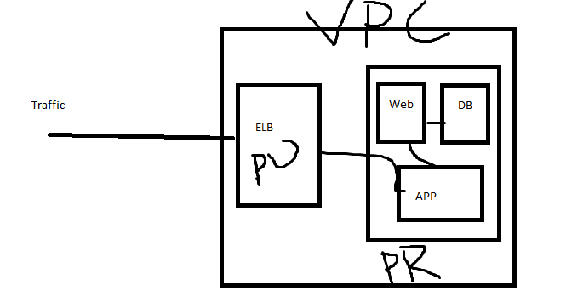

advantages:--

load balancing

health checks (ping to the servers based on our configuration)

SSl -Encryption and Decryption (We have Http and https protocol , Http work on 80 port , https work on 443 port, we can browse from http or https , for https we have lock symbol, https provide security )

if only enable with http then that will send to website with normal text.. if you use any transaction then that time we use card details are any , to secure we use we need to use https then data will be encrypted.request and response will be shared with the data encryption..

high availability

Fault tolerance.. (if one node fail that will send to another)

if we use ssl offloading in ELB that will taker about ssl encryption and decryption...

Types of Load Balancer: ---

_____________________________________________________________________

what are the different types and why devided into these many types..

OSI-- open systems interconnect..

OSI model created by ISO (international standart organization)

7. Application layer (data actions will be 7th layer to 1st layer , request and response will be route from 7th layer to 1st layer).

application level activities all store in application layer (http or https ) , file transfer, email protocol

6. Presentation layer (encryption and decryption transit will be happen in this layer)

5. session layer (session timing related after login)

4. Transport layer (TCP & UDP protocol will have , will convert into different parts and check for any errors , tcp-- wired connection, UDP --> wireless connection)

3. Network layer ( here from which server to which server data should be reach, one IP4 will be allocated ), this is used for logical address

2. Data link (this is used for logical address , every electronic device has MAC address that will be assigned by network interface cards. Mac address will be send to physical )

1. Physical layer

We have four types of Load balancers:---

____________________________________________

Classic load balancer ---> will work on application and transport layer...

Application load balancer ---> will work on application layer ( consider http, https )

Network load balancer ---> will work on Transport layer..(work on layer 4)

Gateway load balancer ----> will work on transport layer and network layer..

Difference b/w load balancer..

______________________________________________________________

1. classic load balancer :-- will not suggest , cost effective and new features are not available so not suggesting this load balancer...

using scenario :-- if use EC2 classic use then must and should use classic load balancer.. another one is VPC with EC2..

Http and https , TCP and UDP protocol will be accepted..

Targets should be direct EC2 instances

this should be balance the load in b/w EC2 instances only...

others will have targets ..

others like EC2 , ECS, IP and Lambda..

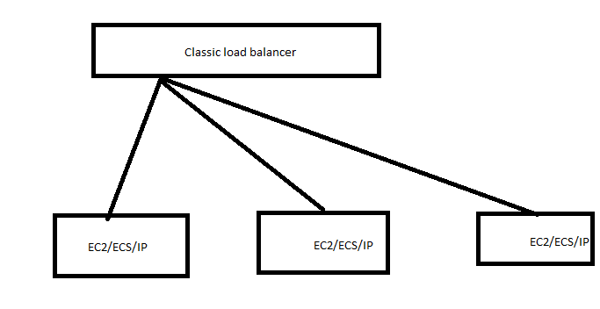

2.. Application load balancer.--->

Advanced to classic load balancer..

should be work under layer seven(protocols should be http and https)

this load balancer will have listeners(nothing but ports) , each listeners will have targets groups... we can add instances under target groups)

request send from URL , rest api headers will replace and authorization will replace and input will be share to server...

based on path that should reach to the perticular application..like fb/abc .. fb/cde .. fb/xyz..

in application load balance only we have

in classic we need to you multiple loadbalancers so we need to use application load balancer..

SSL offloading and ssl termination also supporting.

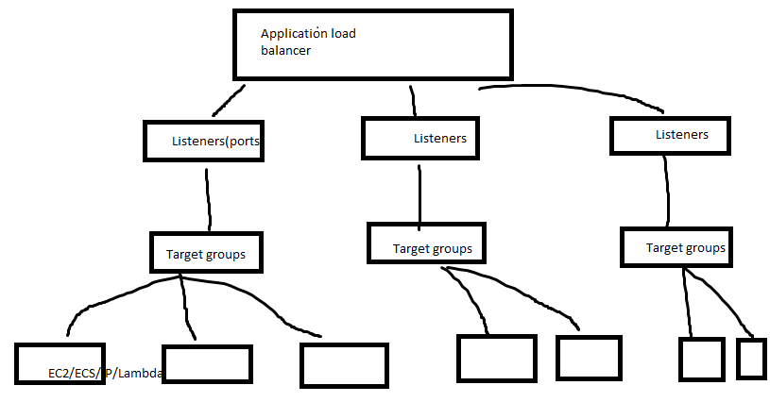

3. Network load balancer: ---

It will work on transport layer..it is not present on application layer so path based routing will not workout.. it should be work on IP and Ports level..based on ip and ports need to configure..

network loadbalancer will give with the lower latency.. speed is high comparing with application load balancer...

as the same this will work as application but difference is protocals .. tcp udp here http and https in application level..

same architecture as application load balancer..

Application and classic will give DNS name (CNAME)

When ever we need Static ip we need to use NLB. based on NIC IP address will generate...

4.Gateway load balancer: will use for security purpose..

layer 4 and layer 3 this work

.

based on access we have two types of load balancers:

____________________________________________________________________

public load balancer and private load balancer..